# Advanced Graphics Coursework

## Screenshots

### Cube World Scene

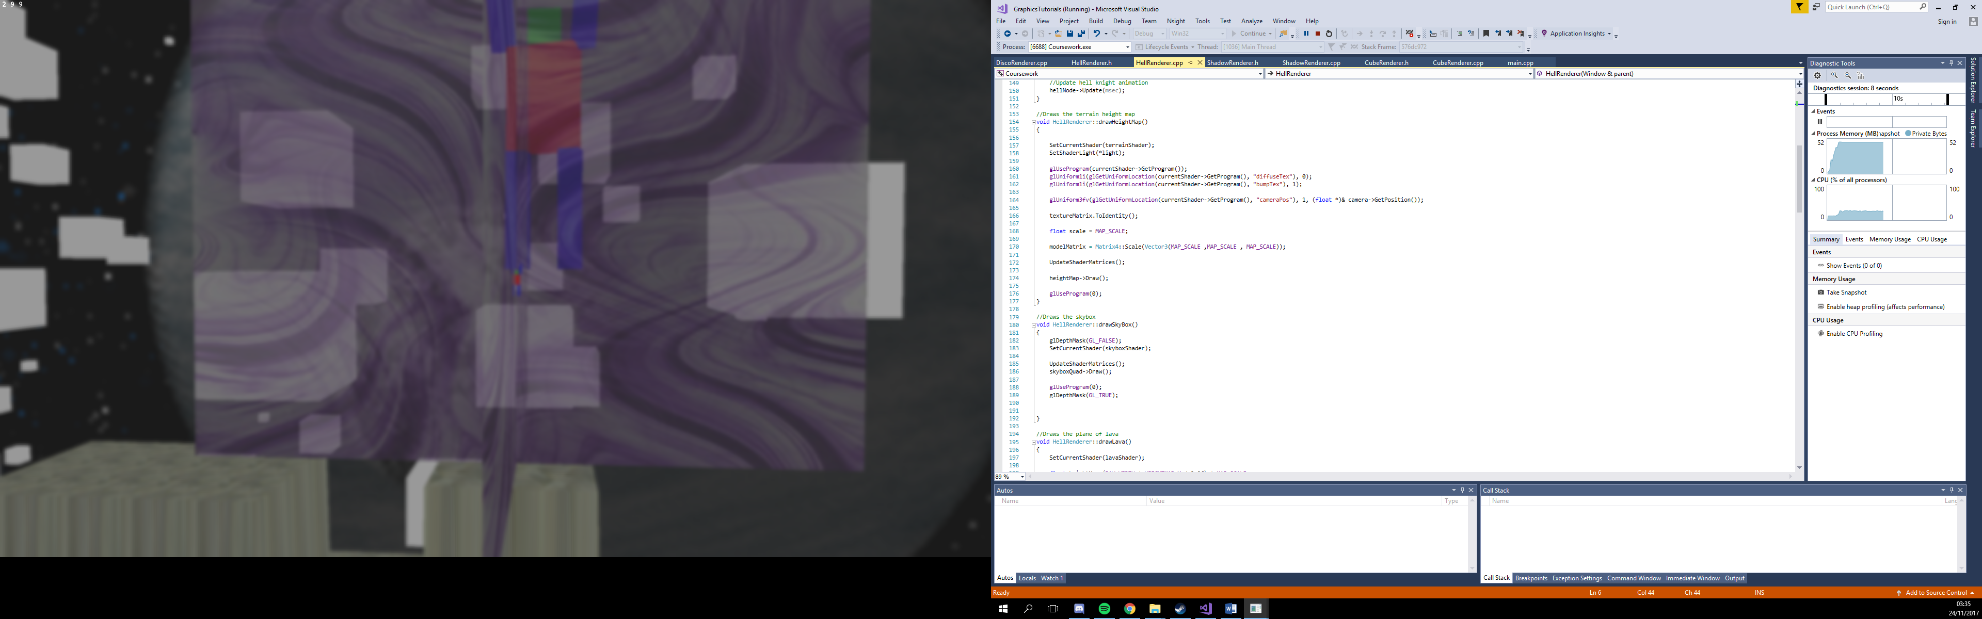

This screenshot shows the cube world scene with blur post processing applied. There is an animated cube robot, as well as a large number of cubes. A transparent set of quads are in the middle, however the terrain underneath is purposefully rendered afterwards so that it can not be seen when looking through the quads. The scene uses a scene graph and nodes to render it and use frustum culling. A space cube map has been applied as a sky box.

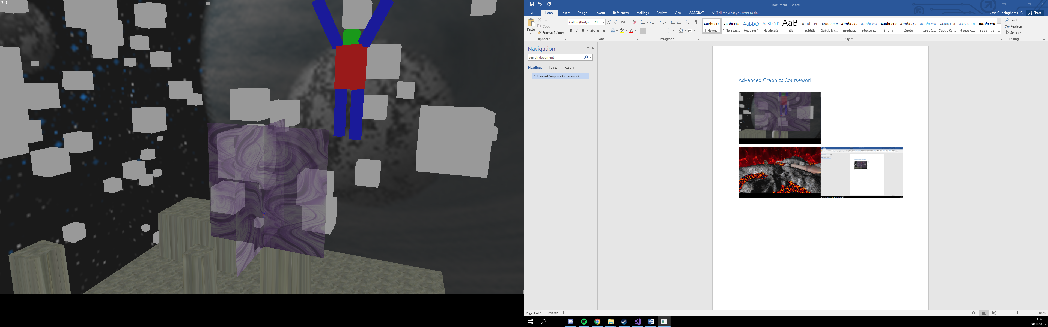

The same scene with the postprocessing turned off.

### Hell Scene

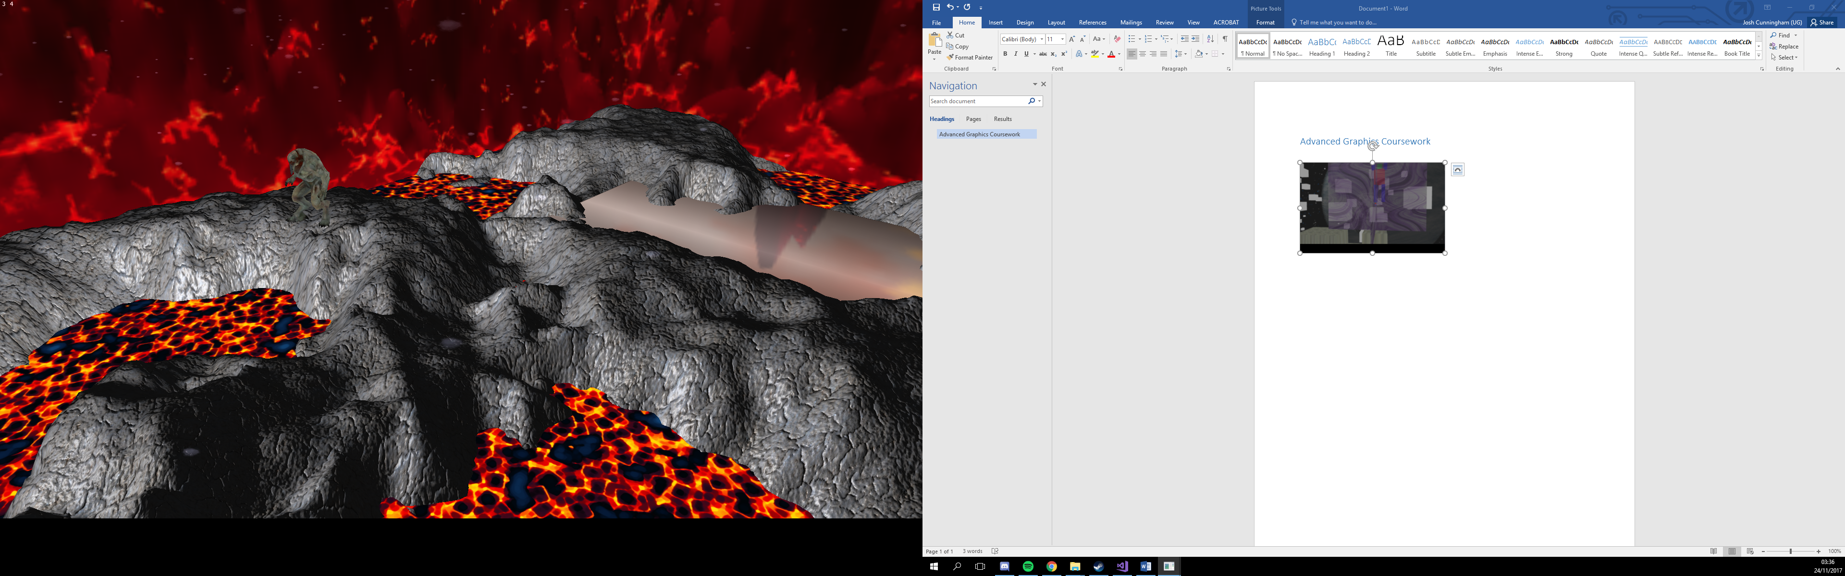

A hell scene using shadows, a height map with a bump mapped texture, an animated hell knight mesh and a reflective surface. A particle emitter has been used to create a smoke effect from the bottom of the terrain. A cube map has also been used to form a skybox.

### Shadow Scene

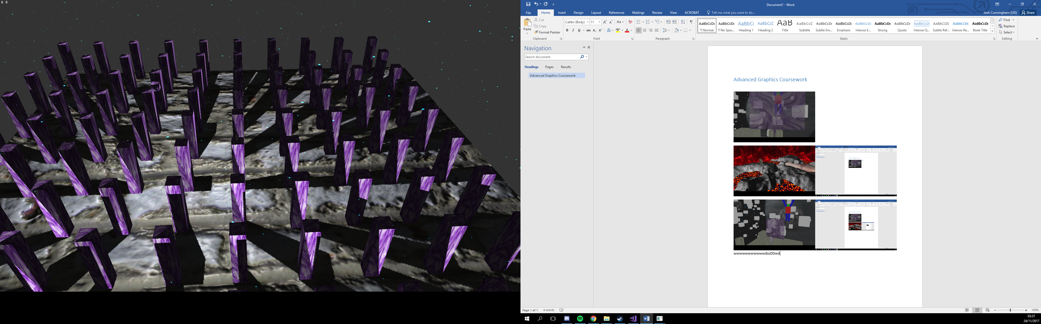

A scene with various cubes acting as pillars. A moving light source moves back and forth drawing shadows using a shadowmap. A particle emitter has also been used to give the effect of it raining.

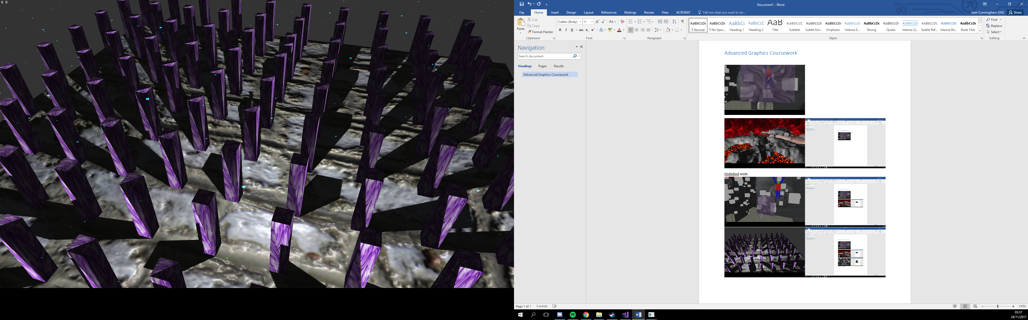

The same seen being rendered using a separate static light source.

## Control Guide

### General

#### Camera Controls

W – Move the camera forward

A – Move the camera left

S – Move the camera down

D – Move the camera right

Shift – Move the camera up

Space - Move the camera down

Mouse - Look using the camera

#### Scene Controls

Left Arrow – Go to previous scene

Right Arrow – Go to next scene

P – Pause the scene transition timer (usually swaps scenes after 30 seconds)

### Scene Specific

#### Cube World

Up Arrow – Increase post processing passes to blur scene more

Down Arrow – Decrease post processing passes to reduce blur

#### Shadow Scene

Up Arrow – Switch light source being used

## YouTube Link

https://youtu.be/KG3b4AjzyYc